

**School of Science and Technology**

Embedded Systems ITEC40091

# Design and implementation of wireless sensor network for guide robot

By

Salim Sulaiman Maaji

N0726366

MRes Electronic Systems

**TUTOR(S) :** Pedro Machado

**Date:** 05/31/2018

# Declaration

“I am aware of the University’s rules on plagiarism and collusion and I understand that, if I am found to have broken these rules, it will be treated as Academic Misconduct and dealt with accordingly. I understand that if I lend this piece of work to another student and they copy all or part of it, either with or without my knowledge or permission, I shall be guilty of collusion.

• In submitting this work I confirm that I am aware of, and am abiding by, the University’s expectations for proof-reading.

• I understand that I must submit this coursework by the time and date published. I also understand that if this coursework is submitted late it will, if submitted within 5 working days of the deadline date and time, be given a pass mark as a maximum mark. If received more than 5 working days after the deadline date and time, it will receive a mark of 0%. For referred or repeat coursework, I understand that if the coursework is not submitted by the published date and time, a mark of 0% will be automatically awarded.

• I understand that it is entirely my responsibility to ensure that I hand in my full and complete coursework and that any missing pages handed in after the deadline will be disregarded.

• I understand that the above rules apply even in the eventuality of computer or other information technology failures.”

# Abstract

It is estimated that 285 million people are visually impaired worldwide in 2014. 39 million are blind and 246 million have poor vision. These people need help to avoid obstacles, choose items when they go shopping and identify signage such as those in roads and buildings. An embedded sensor network that communicates in a simplex communication is designed and configured to be used as a guide robots for blind people.

# Table of contents

Contents

Design and implementation of wireless sensor network for guide robot 1

Declaration 2

Abstract 2

Table of contents 2

Introduction 2

Aim 3

Objectives 3

Components Required: 3

Background 4

Structure of wireless sensor network 4

Related works 4

Experimental methodology 5

Project design 5

Technical design 6

Result and discussion 8

Conclusion 9

Future work 10

Bibliography 10

# 

# Introduction

We live in the era of information and communication technology, robots are being programmed to mimic the behavior of human. In the near future, robots will face a huge deployment to aid people's everyday lives.(Pacaux-Lemoine *et al.*, 2017). There is a growing interest in using wireless a sensor network (WSN), especially for robotic system design, forest fire detection, aquatic biodiversity mapping among others. (Mal-Sarkar, Sikder and Konangi, 2010) These remarkable achievements will dramatically change people’s life. However these changes have largely not affected blind According to the world health organization, 285 million people are estimated to be visually impaired worldwide in 2014. 39 million are blind and 246 million have poor vision.(World Health Organization, 2017) Majority of these people live in developing countries. These people need help to avoid obstacles, choose items when they go shopping and identify signage such as those in roads and buildings. Helping these people is as important as caring for them. Although GPS technology has been used in applications like google maps and maps me, however this technology has some limitations, as it cannot be used to navigate inside an indoor facility. The main purpose of this project is to design an embedded sensor network that communicates in a simplex communication to be used for guide robots for blind people. This technology will help the blind user to navigate accurately without the need for GPS signal.

The remainder of this project is organized as follows: Section II presents a background on the sensor networks,. Section III discusses the Experimental Methodology. Results and discussion are presented in Section IV. Concluding remarks are given in Section V.

# Aim

The main aim of this project is to design an embedded sensor network that communicates in a simplex communication to be used for a guide robots for blind people.

# Objectives

* To understand the basic of sensor networks.
* To Implement hardware connection for the sensors.
* To program the boards in an embedded system platform

## Components Required:

1. 2 Zigbees
2. Ultrasonic Range Finder, used to measure distance
3. Light Dependent Resister , light sensor
4. 10 kill ohms resistor
5. Buzzer
6. Red LED Lights
7. 3*Green LED Lights
8. 3*Yellow LED Lights
9. Breadboard
10. Male To Male Connectors
11. Arduino Leonardo With Ide Cable
12. Battery

# Background

Many electrical and computer systems involve some kind of computing technology in which a microcontrollers, an integrated circuit with processor process and executes controlling task (Russell, 2010). This type of minicomputer is responsible for processing information for human consumptions, such as traffic lights control in a city, running the engine, brakes, seatbelts, airbag, and audio system in a car and commanding robots on a factory floor, this specialized computer system typically operate in, and interact with, an external environment by collecting data through sensors and actuators. Often these network of nodes requires either simplex communication a communication system involving transmitter and receiver, half duplex two pairs of transmitter receiver sharing a single backbone or full duplex communication integrated. (Kim and Jeon, 2009).

## Structure of wireless sensor network

The basic structure of a wireless sensor network (WSN) consists of huge number of low-power, low-cost, battery supplying energy to multifunctional sensing devices and sensors . These sensors devices are deployed in different location for the purpose of monitoring, they are well equipped with a s processor, transceivers, memory resource, actuators and a limited battery device. In this network of devices, each node is able to transfer a packet to the destination(Manju, Chand and Kumar, 2018).(Barani et al., 2018).

The data acquired by the nodes is transmitted to the nearest gateways which can operate independently or convey data to a host system. Gateways are specialized coordinating systems in the network responsible for authentication of the data collected by the nodes and routing the collected data for analysis and processing. The main function of a host system is to process and analyse this data using specially designed software. (Boubiche et al., 2018)

## Related works

(Mustafa, Hansen and Eilertsen, 2014) proposes animal monitoring and localization system using wireless sensor networks. Data is acquired by the help of nodes, and then its transmitted to the gateways which convey data to a host system.(Sun *et al.*, 2011) Applied sesnsor network for post-disaster road monitoring system, to aid the blocked of roads after earthquake was presented . Sensor network technology for real-time dynamic data of the road availability was designed. (Ye, Gong and Wang, 2009) propped a system of WMS that monitors several environmental parameters for environmental monitoring. underground water level, barometric pressure, ambient temperature, atmospheric humidity, wind direction, wind speed and rainfall were measured. And (Shen *et al.*, 2008) Predict wind power output in real time using a cluster of WNSs .

# Experimental methodology

## Project design

The integrated project consists of 3wo parts – (A) data acquisition (B) pre-processing and (C) output implementation. The feature processing is designed to work in two modes:

**Normal mode:** The guide robot is a **sound**-guided object designed to detect an obstacle at least several meters ahead. It has two parts, range finding and transmission node where the sensor network is located and Gateway part for data collection, and analysis for decision making. The flowchart for the integrated project is shown below

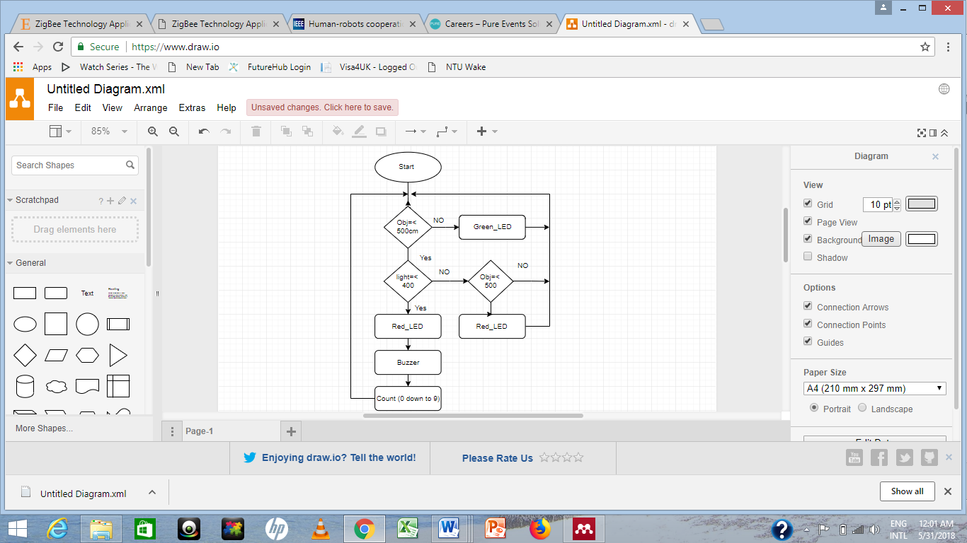

Figure 1Flowchart for the integrated design

The obstacles present could be either dynamic, or static. At normal operating condition the green light on indicating everything is fine, however when the object is detected less than 400cm a red light will light with buzzer sound beefing at once to notify the blind and object is near.

Night Mode: At night mode, if an object is detected less than 400cm, red light will turn on and buzzer will beef. A down counter is set to continue counting from 9 to 0, then the buzzer stops.

## Technical design

The project is designed in an embedded system platform using Arduino an open source hardware/software platform for the development of electronic systems based on Atmel microcontrollers.(kim, et.al 2009). It has several advantages over other microcontroller platforms, such as availability in the market at low price and software includes a variety of libraries for different purposes and it can easily be integrated with different wireless sensors. There are two functions to write a program in arduino : setup() and loop(). The former is used for hardware setup and variable initialization. The most common task for hardware setup is to deﬁne whether a port will be used as input or output. The later function is the equivalent to the main() function. Detail codes are available at Github

The range finding and transmission node was designed with ultrasound range finder; this object uses ultrasonic technology to measure the distance between 1cm and 4m. (Robot-electronics, 2018).The principle of working for this device is the ability to provides an echo pulse measured in uS which is proportional to distance. In this project, the width of the pulse is divided by 58 which give us distance cm, the device has 5 pins and are connected to the arduino board accordingly as shown in the figure below.

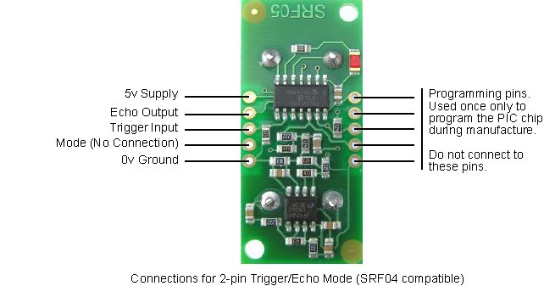

Figure 2Range finding(Robot-electronics, 2018)

When the distance is captured in uS, Zeegbe will than transmit the data to the next board which is a Gateway part for data collection, and analysis.



Figure 3 Zigbee (Robot-electronics, 2018)

The rationality behind using Zigbee in this project over other means of wireless communication for short distance are, for infrared is a point to point transmission, it has dificulties in building flexible network and it can easily be blocked by other. Wifi has high speed transmitting rate, effective communication range but it is costly and consume more power hence it’s not suitable for longtime working networks. Bluetooth device only allows seven slaves to be connected to it. On the other hand Zigbee can be used for effective communication network and low power consumption . The two Zigbees communicating with each other effectively and Gateway receives the distance in cm.

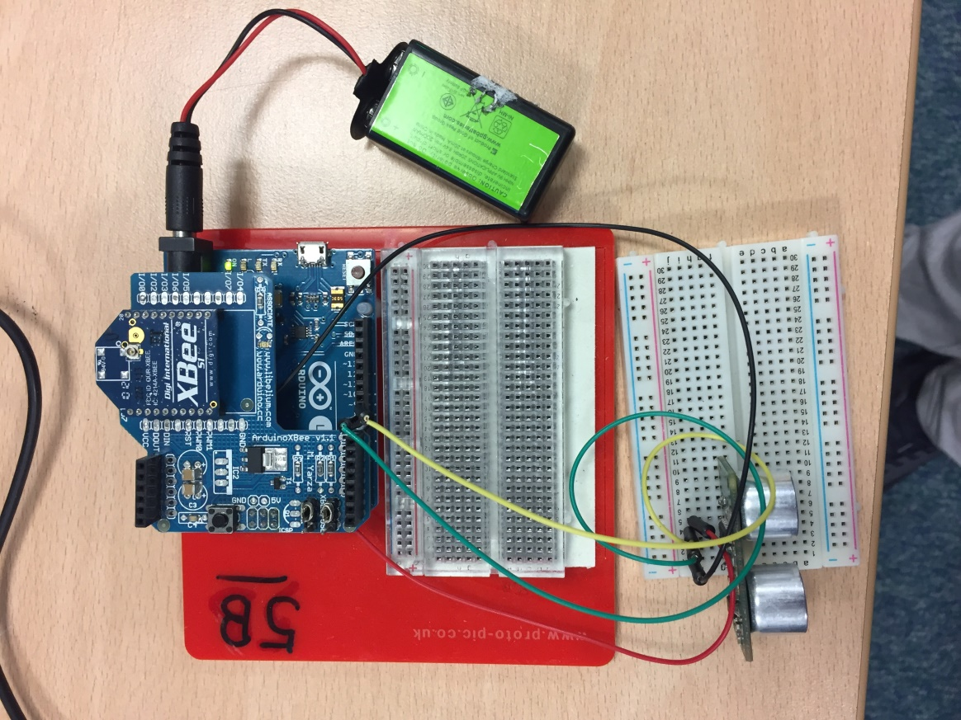

Figure 4 Transmitting board

On the other hand, the connection on the receiving board consist of light dependent resistor (LDR) connected to 10k-ohm resistor and connected to Analogue interface pin, the buzzer and LCD are connected as shown on the figure below.

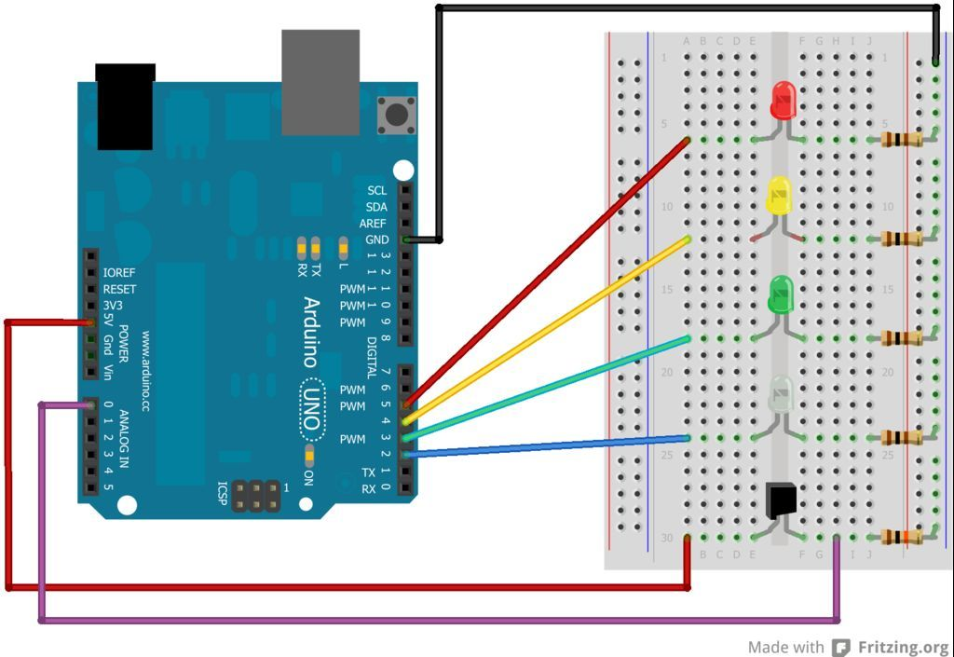

Figure 5 Circuit connection (Robot-electronics, 2018)

# Result and discussion

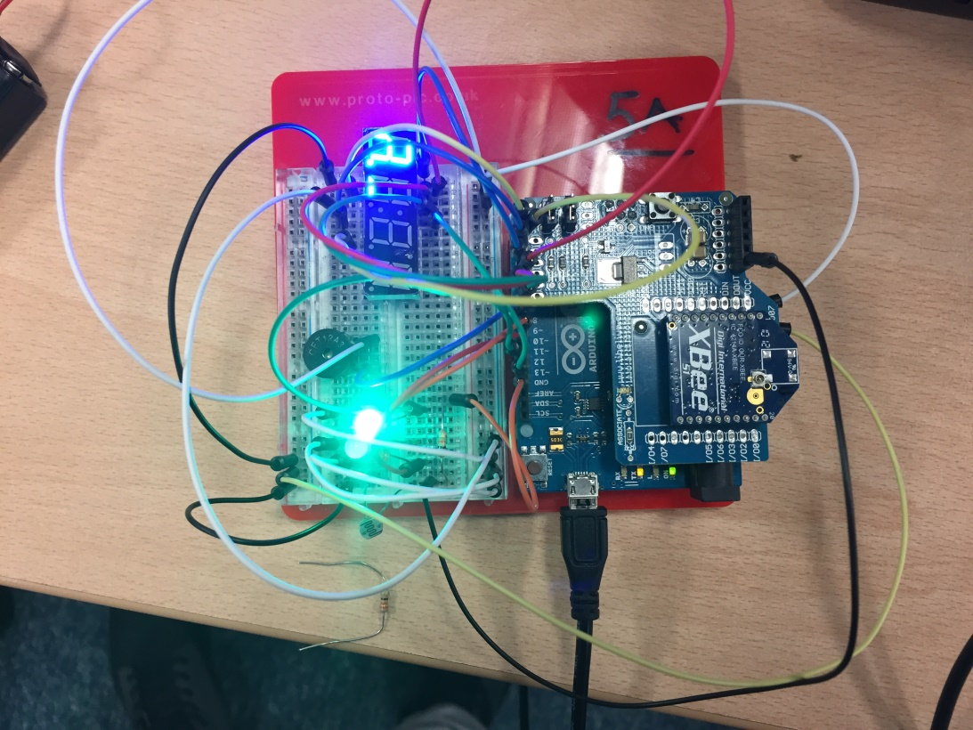

Figure 6 Recieving board

This section presents are result of the experiment carried out between sending board and receiving board. Board B acts as coordinator, and is the first node to be connected to the network, board A is the router. Conditions were written for board B to be sending “n” if the range finder distance is greater than 500cm and to transmit “e” if the distance is less than 500cm.

As it can be seen on the board A in the figure green LED is on when the distance is normal mean the obstacle is not in the red zone. However when the object is close to i.e less than 500cm, red LED is light on and bazzer beef until the counter counts from 9 down to 0.

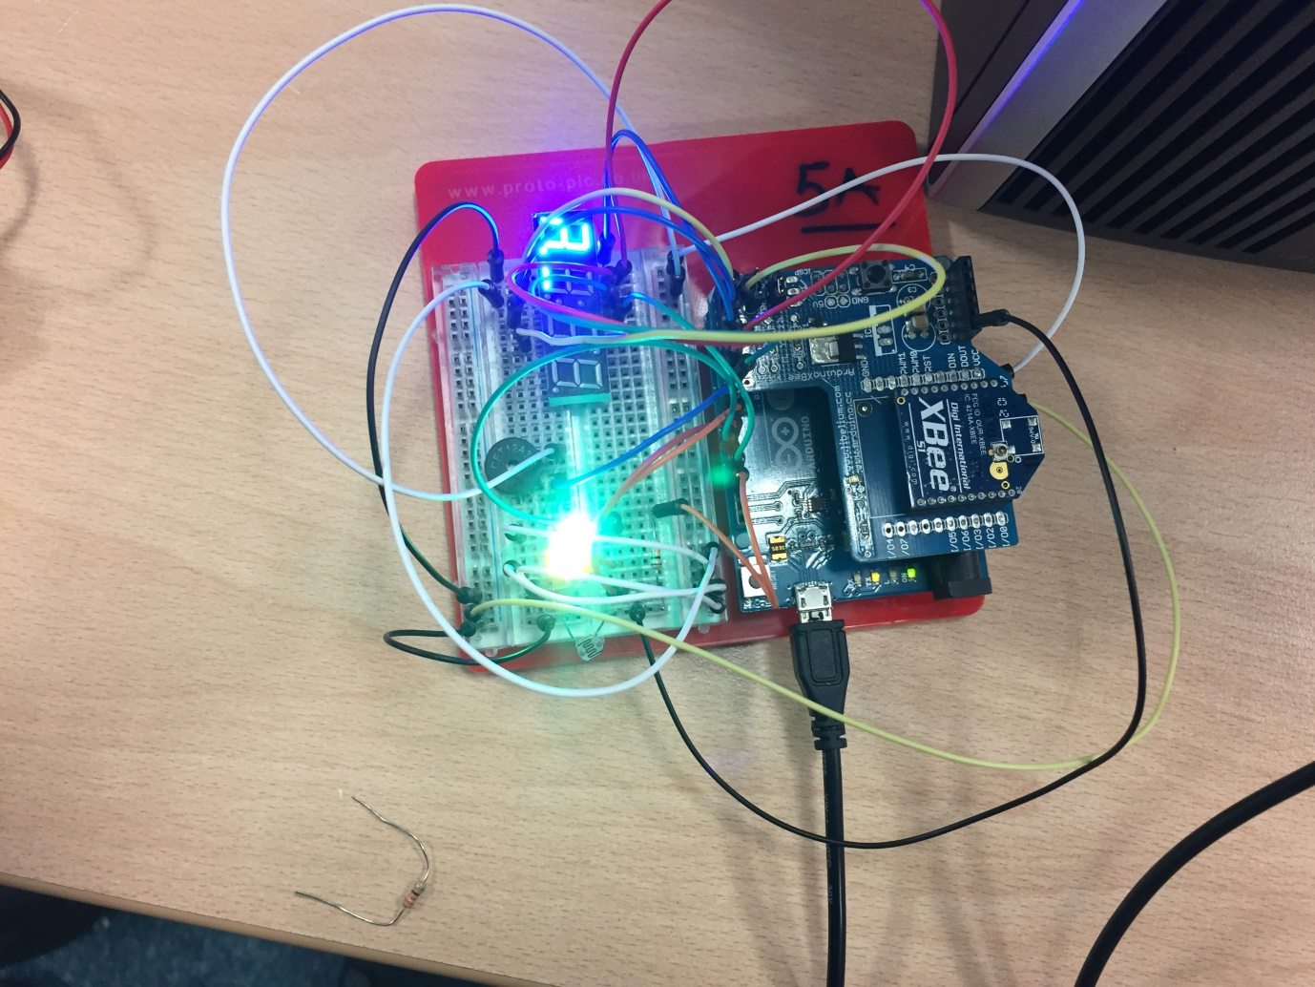

Figure 7 Receiving board

From the result obtained it can be seen that a Zigbee module can operates as stand-alone device when connected with battery or it can be attached to a computer. In this project battery was used for board B, sending sensor data to a central node which is board A connected to a computer source. When the serial monitor was open the result shows that the boards were able to establish serial communication, and the output of the result was shown on the serial monitor. When an XBee module is connected to an intelligent device (such as a computer, Arduino, or Raspberry Pi), it uses serial communication.

# Conclusion

In conclusion an embedded sensor network system that communicates in a simplex communication is designed. This technology is to be used for a guide robots for blind people to navigate accurately without the need for GPS signal. From the result obtain Zigbee module can operates as stand-alone device when connected with battery or it can be attached to a computer. Board B acts as coordinator, and is the first node to be connected to the network, board A is the router. Conditions were written for board B to be sending “n” if the range finder distance is greater than 500cm and to transmit “e” if the distance is less than 500cm.

# Future work

To add some feature using AI that can aid the blind people navigate easily the features are: (A) image processing and (B) text to speech conversioThe image processing will be designed to work in three modes: Obstacle detection mode: My companion works like a vision-guided mobile application designed to detect an obstacle at least several meters ahead. The image captured by the camera is processed and analysed. Reading mode: A text is read by character recognition. Colour detection mode: This colour detection technology can help a blind person when crossing a street, on the pedestrian traffic light camera. The captured image can be processed and thus, the colour on the traffic light can be detected using a procedure that compares the captured colour pixel with RGB red, green and blue values. A voice feedback will then be used to tell a user “go when it’s blue and stop when it is red”. This technology can also be extended when a blind person goes for shopping, and the apps can tell him the actual colour of item he picked.

# Bibliography

Barani, H. *et al.* (2018) ‘Effect of sink location and redundancy on multi-sink wireless sensor networks: a capacity and delay analysis’, *IET Communications*, 12(8), pp. 941–947. doi: 10.1049/iet-com.2017.1040.

Boubiche, S. *et al.* (2018) ‘Big Data Challenges and Data Aggregation Strategies in Wireless Sensor Networks’, *IEEE Access*, 6, pp. 20558–20571. doi: 10.1109/ACCESS.2018.2821445.

Kim, S. H. and Jeon, J. W. (2009) ‘Introduction for Freshmen to Embedded Systems Using LEGO Mindstorms’, *IEEE Transactions on Education*, 52(1), pp. 99–108. doi: 10.1109/TE.2008.919809.

Mal-Sarkar, S., Sikder, I. U. and Konangi, V. K. (2010) ‘Application of wireless sensor networks in forest fire detection under uncertainty’, in *2010 13th International Conference on Computer and Information Technology (ICCIT)*, pp. 193–197. doi: 10.1109/ICCITECHN.2010.5723853.

Manju, Chand, S. and Kumar, B. (2018) ‘Target coverage heuristic based on learning automata in wireless sensor networks’, *IET Wireless Sensor Systems*, 8(3), pp. 109–115. doi: 10.1049/iet-wss.2017.0090.

Mustafa, M. Y., Hansen, I. and Eilertsen, S. (2014) ‘Application of wireless sensor networks based on cognitive radio for animal welfare’, in *2014 5th IEEE Conference on Cognitive Infocommunications (CogInfoCom)*, pp. 499–503. doi: 10.1109/CogInfoCom.2014.7020508.

Pacaux-Lemoine, M. P. *et al.* (2017) ‘Human-robots cooperation through intelligent garment’, in *2017 IEEE 26th International Symposium on Industrial Electronics (ISIE)*, pp. 1996–2001. doi: 10.1109/ISIE.2017.8001560.

Robot-electronics (2018) *SRF05 - Ultra-Sonic Ranger Technical Specification*. Available at: https://www.robot-electronics.co.uk/htm/srf05tech.htm.

Russell, D. (2010) *Introduction to Embedded Systems: Using ANSI C and the Arduino Development Environment*, *Introduction to Embedded Systems: Using ANSI C and the Arduino Development Environment*. Morgan & Claypool. doi: 10.2200/S00291ED1V01Y201007DCS030.

Shen, L. *et al.* (2008) ‘Application of Wireless Sensor Networks in the Prediction of Wind Power Generation’, in *2008 4th International Conference on Wireless Communications, Networking and Mobile Computing*, pp. 1–4. doi: 10.1109/WiCom.2008.959.

Sun, X. G. *et al.* (2011) ‘Application of Wireless Sensor Networks in Post-Disaster Road Monitoring System’, in *2011 4th International Conference on Intelligent Networks and Intelligent Systems*, pp. 105–108. doi: 10.1109/ICINIS.2011.10.

World Health Organization (2017) *Blindness and visual impairment*. doi: 5/30/2018.

Ye, D., Gong, D. and Wang, W. (2009) ‘Application of wireless sensor networks in environmental monitoring’, in *2009 2nd International Conference on Power Electronics and Intelligent Transportation System (PEITS)*, pp. 205–208. doi: 10.1109/PEITS.2009.5407035.